**PL/SQL PROGRAMMING**

**1.Control Structures:  
  
Scenario 1: Discount for Customers Above 60**

**Code:**

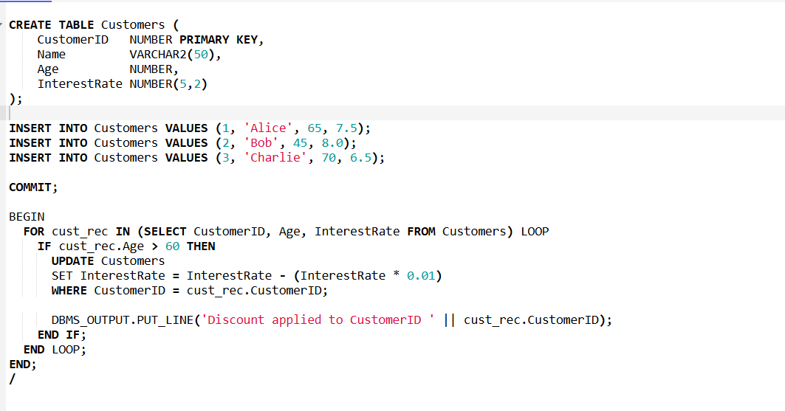

**Output:**

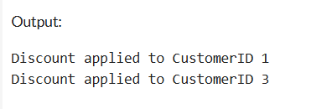

**Scenario 2: VIP Status Based on Balance**

**Code:**

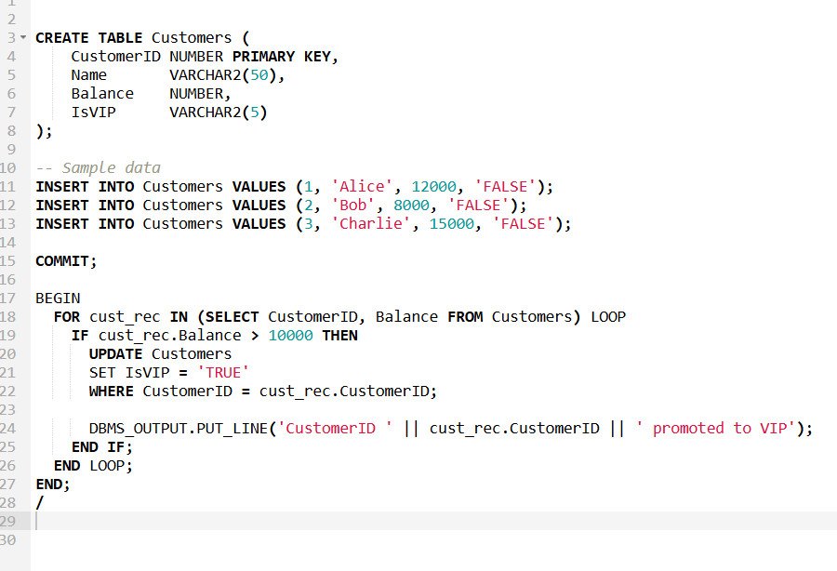

**Output:**

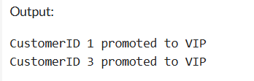

**Scenario 3: Loan Reminders for Due Loans**

**Code:**

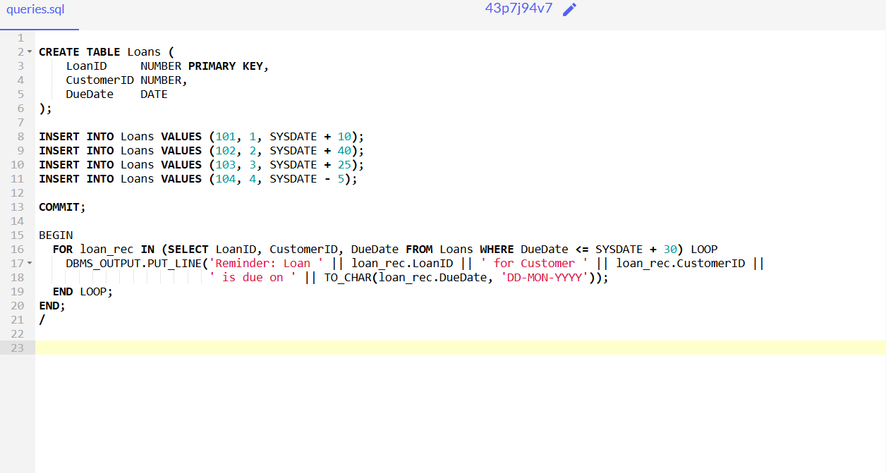  
  
**Output:**  
  
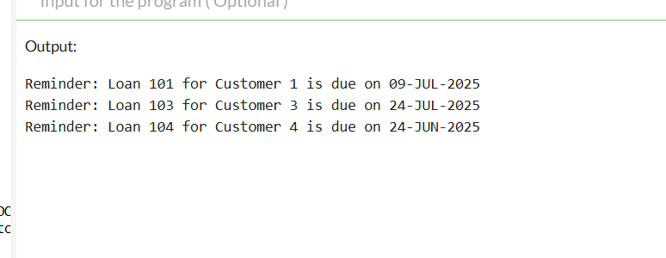

**Exercise 3 : Stored Procedures**

**Scenario 1: Process Monthly Interest for Savings Accounts**

**Code:**  
  
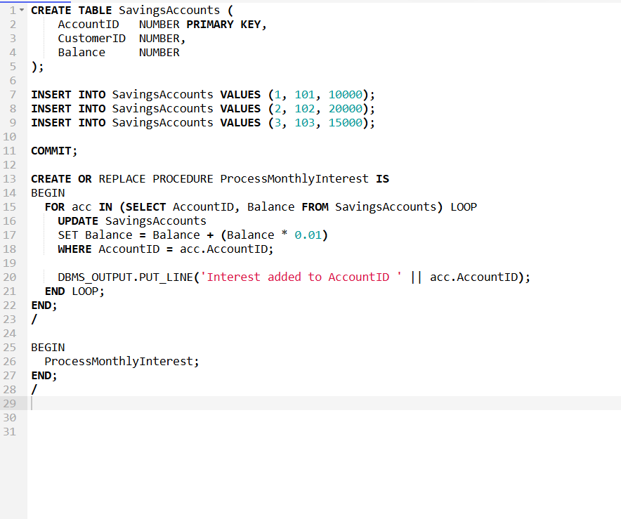  
  
**Output:**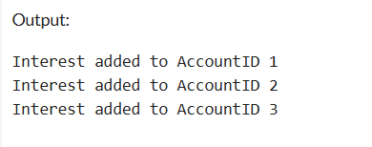

**Scenario 2: Update Employee Bonus by Department**

**Code:  
  
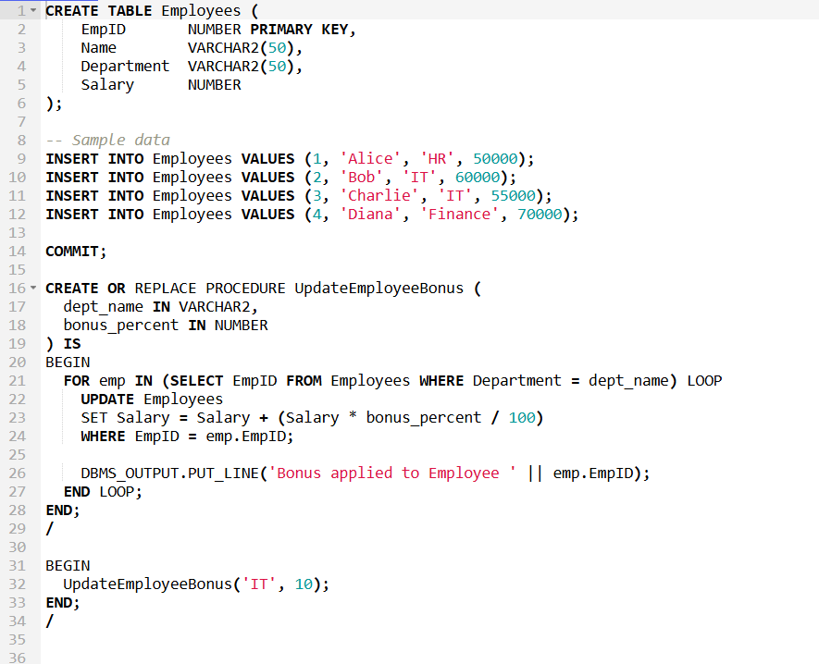  
  
  
Output:**

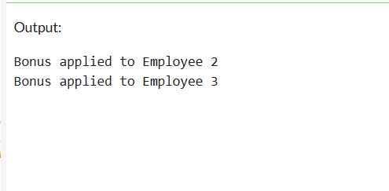

**Scenario 3: Transfer Funds Between Accounts  
  
Code:  
  
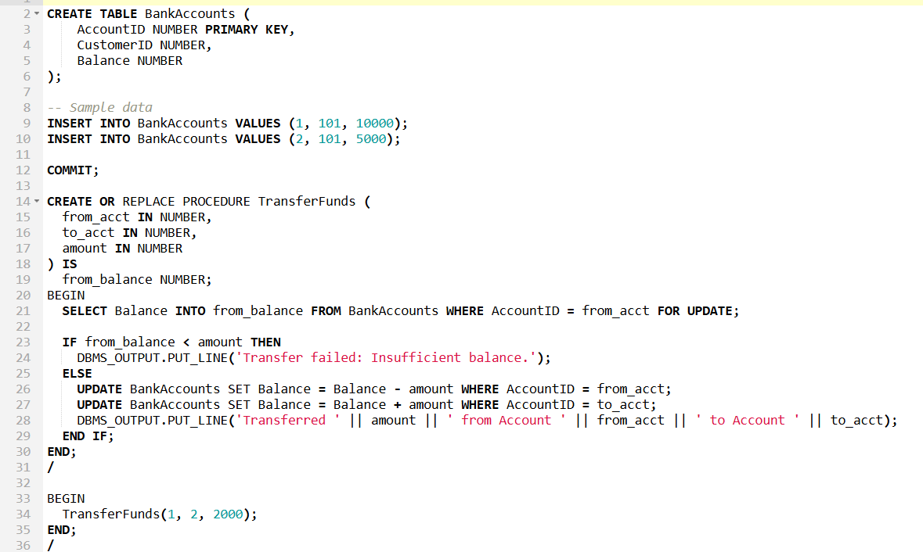**

**Output:  
  
